# **SLTC re:Start Bootcamp**

# **Final Assignment (Group project)**

# Project name: Online Car Dealer

# Team members:

|  |  |
| --- | --- |
| **Student ID** | **Full Name** |
| BC1111 | H A Onila Wasuru Pemathunghe |
| BC1930 | Thamali Nipunika Palliyaguruge |

# GitHub URL: https://github.com/SLTC-GroupProject/CarDealer

# Demo URL (if available):

Contents

**SLTC re:Start Bootcamp** 1

**Final Assignment (Group project)** 1

Project name: Online Car Dealer 1

Team members: 1

GitHub URL: https://github.com/SLTC-GroupProject/CarDealer 1

Demo URL (if available): 1

Technical Documentation 3

Introduction 3

Navigation map 7

Sample UI 10

Database relationship (ER) diagram 13

Use Case Diagram 14

Use Case Description for Create Account 14

Use Case Description for Login 15

Use Case Description for View advertisements 16

Use Case Description for Manage User Accounts 18

Use Case Description for Manage Advertisements 19

Use Case Description for Comment, Rate on Advertisements, Report on Fraud Advertisements and Mark Favorite Advertisements 20

Use Case Description for View Reports 20

Business logic 22

Final screenshots 23

# 

# Technical Documentation

## Introduction

Classified advertising is one of the most common modes of advertising in the world. This is more effective and economic way of advertising because it helps to address larger audience with actual requirement. Today with the advancement of Information Technology, this classified advertising concept develop up to online classified advertising portal.

Online Car Dealing system also a kind of a classified advertising portal. These have become most effective platform to meet advertisers and viewers because we provide advanced facilities than traditional classified advertising such as quick sorting, filtering and searching advertisement according to the requirements and quick process for crating advertisement for advertisers.

**Objectives:**

The aim of this project is to identify the issues and drawbacks of existing online car dealing systems and to provide a better solution for the users with much usability and efficiency.

* To provide an online platform to meet advertisers and viewers with matching requirements.
* To provide a user-friendly environment so that advertiser can post their advertisement conveniently and free of cost.
* To provide a user-friendly environment for viewers with advance filtering features to sort appropriate advertisement to their requirements.
* Provide excellent and easy to access means of communication medium between advertisers and viewers.
* To provide an online platform with trustworthy advertisers and cars.

**Scope:**

This system will cover following functionalities.

* Advertisers will be able to post advertisements.
* Advertisers will be able to insert the exact location of the commodity or service via Google Map if they prefer.
* Viewers will be able to view, search and sort advertisements
* Viewers will be able to report, rate and comment on advertisement.

**Design Overview:**

The developed system will basically contain two frontend views, one for users of the website and other

view for administrators of the site. Frontend view for the unregistered user support user for advertisement viewing and account creation. For a registered user for process of advertisement creation and all functions of the unregistered user. The frontend view for the administrators will allow them to view report, handle user accounts, handle advertisement and reported fraud advertisements.

The backend of the website will connect the administrators and users of the website with the server and database.

A pre-selected set of color scheme and logos are designed to for unique identification of the developed system.

**Programming languages and Development tools:**

In its web application or the main view for many users, it includes HTML view. The most important facts considered when selecting programming languages are the ability to develop a highly user-friendly environment for users because users in different levels from age, knowledge level etc. use this system. Also, all the technologies used system should be reliable as relatively high number of users interact with this system with their sensitive data.

After considering all these factors, **React JS along with HTML, CSS, Bootstrap**, is used to develop frontend of this system in the visual studio code source code editor.

Backend of the system was developed using **.NET framework, C#, LINQ using Visual Studio** as the IDE because the system’s backend must have properties like handle large amount of data, robust, validation, frequent authorization etc.

Google maps were used as third party library to implement ‘insert location’ function which is a crucial function in this system.

* **React JS**

ReactJS is an open-source JavaScript library which is used for building user interfaces specifically for single page applications. It’s used for handling view layer for web and mobile apps. React also allows us to create reusable UI components. React was first created by Jordan Walke, a software engineer working for Facebook. React allows developers to create large web applications which can change data, without reloading the page. The main purpose of React is to be fast, scalable, and simple. It works only on user interfaces in application. This corresponds to view in the MVC template. It can be used with a combination of other JavaScript libraries or frameworks, such as Angular JS in MVC.

* **HTML 5**

The standard markup language for creating web pages and web applications with Cascading Style Sheets (CSS) and JavaScript is the HTML. HTML uses markup to describe the structure of web pages. HTML page is developed by HTML elements represented by tags. The browser is responsible for not displaying the tags, but the content when HTML code loaded into browser.

* **JavaScript**

JavaScript is known for one of the most powerful dynamic programming languages for creation and development of web pages. Significant capabilities of this languages are the browser control, content editing on a displayed document, client-side scripts allowance to communicate with users and also asynchronous communication.

* **CSS**

Cascading Style Sheets (CSS) is a style sheet language used for describing the presentation of a document written in a markup language. Although most often used to set the visual style of web pages and user interfaces written in HTML and XHTML, the language can be applied to any XML document, including plain XML, SVG and XUL, and is applicable to rendering in speech, or on other media. Along with HTML and JavaScript, CSS is a cornerstone technology used by most websites to create visually engaging webpages, user interfaces for web applications, and user interfaces for many mobile

applications.

* **.NET framework**

The .NET Framework is the infrastructure for the new Microsoft .NET Platform. The .NET Framework is a common environment for building, deploying, and running Web Services and Web Applications. The .NET Framework contains common class libraries - like ADO.NET, ASP.NET and Windows Forms - to provide advanced standard services that can be integrated into a variety of computer systems. The .NET Framework is language neutral. Currently it supports C++, C#. The new Visual Studio.NET is a common development environment for the new .NET Framework. It provides a feature-rich application execution environment, simplified development and easy integration between a number of different development languages.

* **LINQ**

LINQ (Language Integrated Query) is uniform query syntax in C# to retrieve data from different sources and formats. It is integrated in C# thereby eliminating the mismatch between programming languages and databases, as well as providing a single querying interface for different types of data sources, LINQ is a structured query syntax built in C# to retrieve data from different types of data sources such as collections, ADO.Net Dataset, XML Docs, web service and MS SQL Server and other databases

* **Microsoft SQL SERVER**

MS SQL Server is a relational database management system (RDBMS) developed by Microsoft. This product is built for the basic function of storing retrieving data as required by other applications. It can be run either on the same computer or on another across a network.

**Third party components/libraries**

* **Bootstrap**

Bootstrap is a free and open-source front-end framework for designing websites and web applications. It contains HTML- and CSS-based design templates for typography, forms, buttons, navigation and other interface components, as well as optional JavaScript extensions. Unlike many earlier web frameworks, it concerns itself with front-end development only.

**Hardware Requirements of the external users:**

Hardware Requirements of the external users (viewers and advertisers) machine should have following requirements in order to interact with system,

* Processor (CPU) with 2 gigahertz (GHz) frequency or above
* A minimum of 2 GB of RAM
* Monitor Resolution 1024 X 768 or higher
* Internet Connection Broadband (high-speed) Internet connection with a speed of 4 Mbps or higher
* Keyboard and a Mouse or some other compatible pointing device

**Software Requirements of the external users:**

* Operating system – Windows 7, Windows 8 or Windows 10 Mac OSX 10.8, 10.9, 10.10 or 10.11
* Web Browser – Chrome (Recommended), Firefox Edge
* Backend software – Visual studio (if you’re running locally)

**Web Server Requirements:**

Combined Web & Database Server (minimal) Web server with internet connection. Hardware configuration,

* Core i3 or above processor 2 x 1,6 GHz CPU
* 3.5 GB or above RAM
* 1x 40 GB of free space or more is recommended for the web shop data

## Navigation map

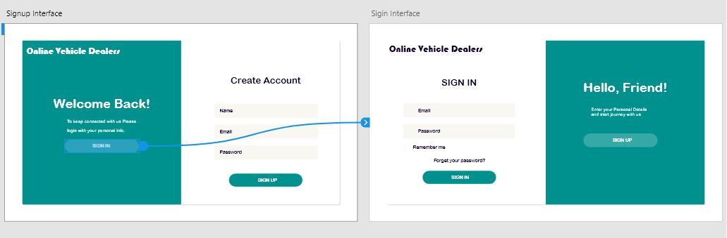

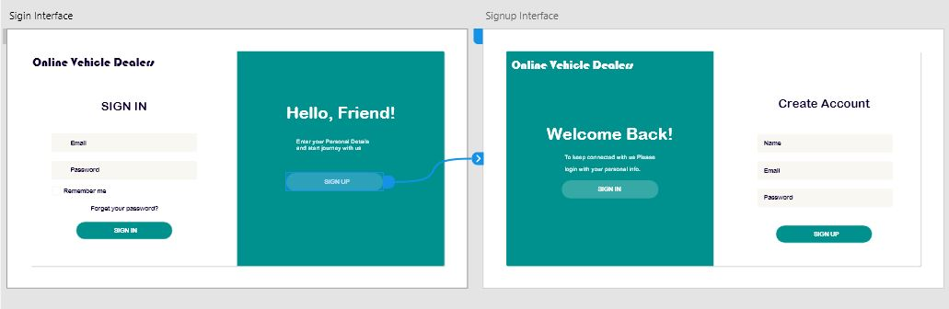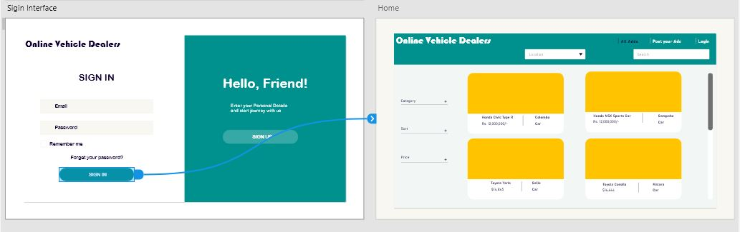

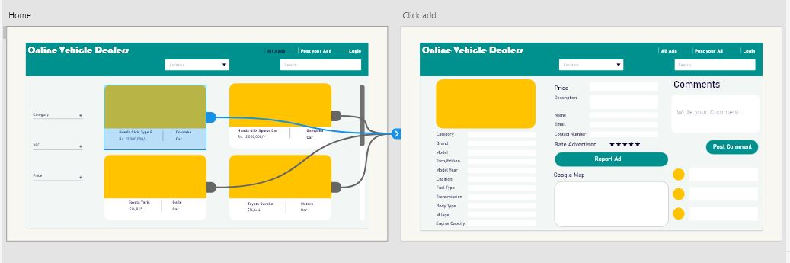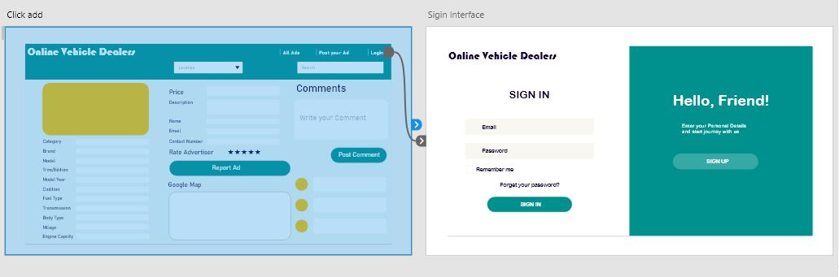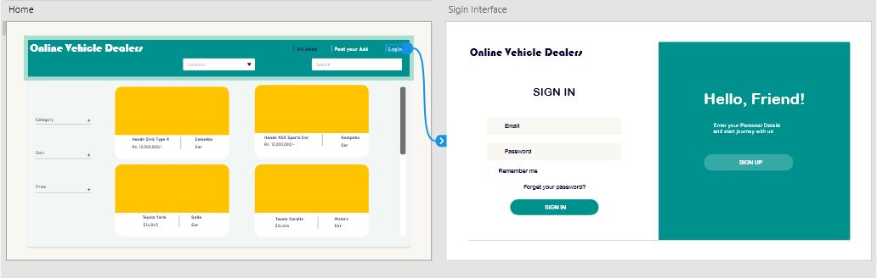

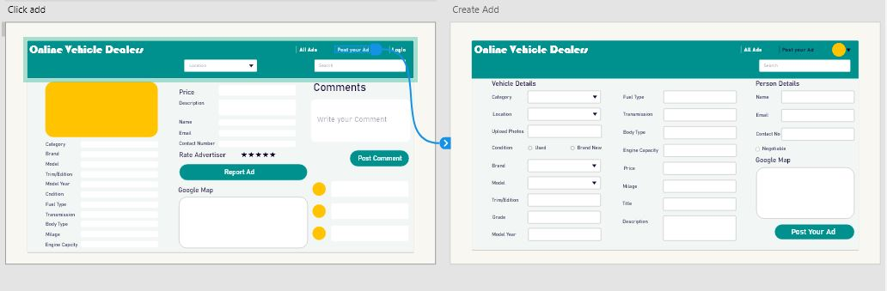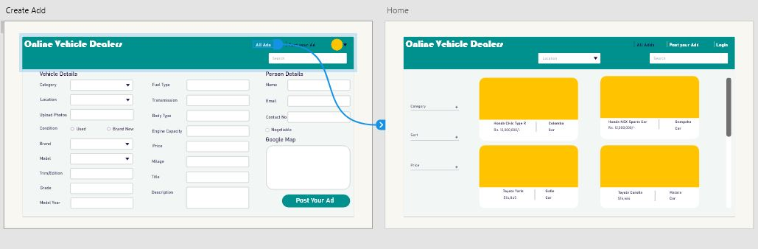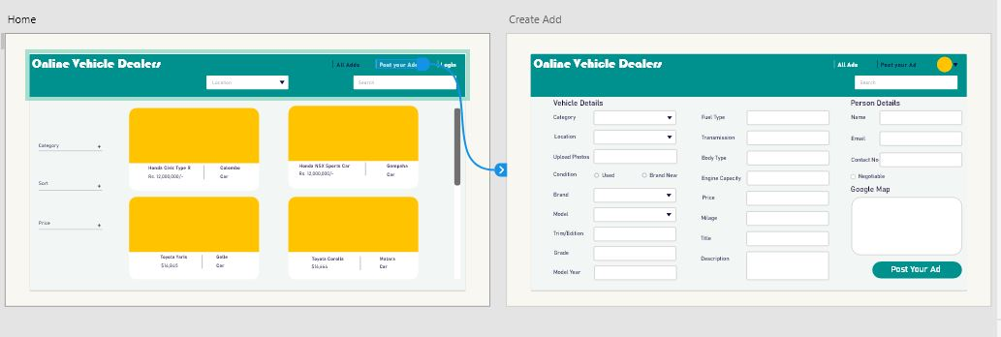

## Sample UI

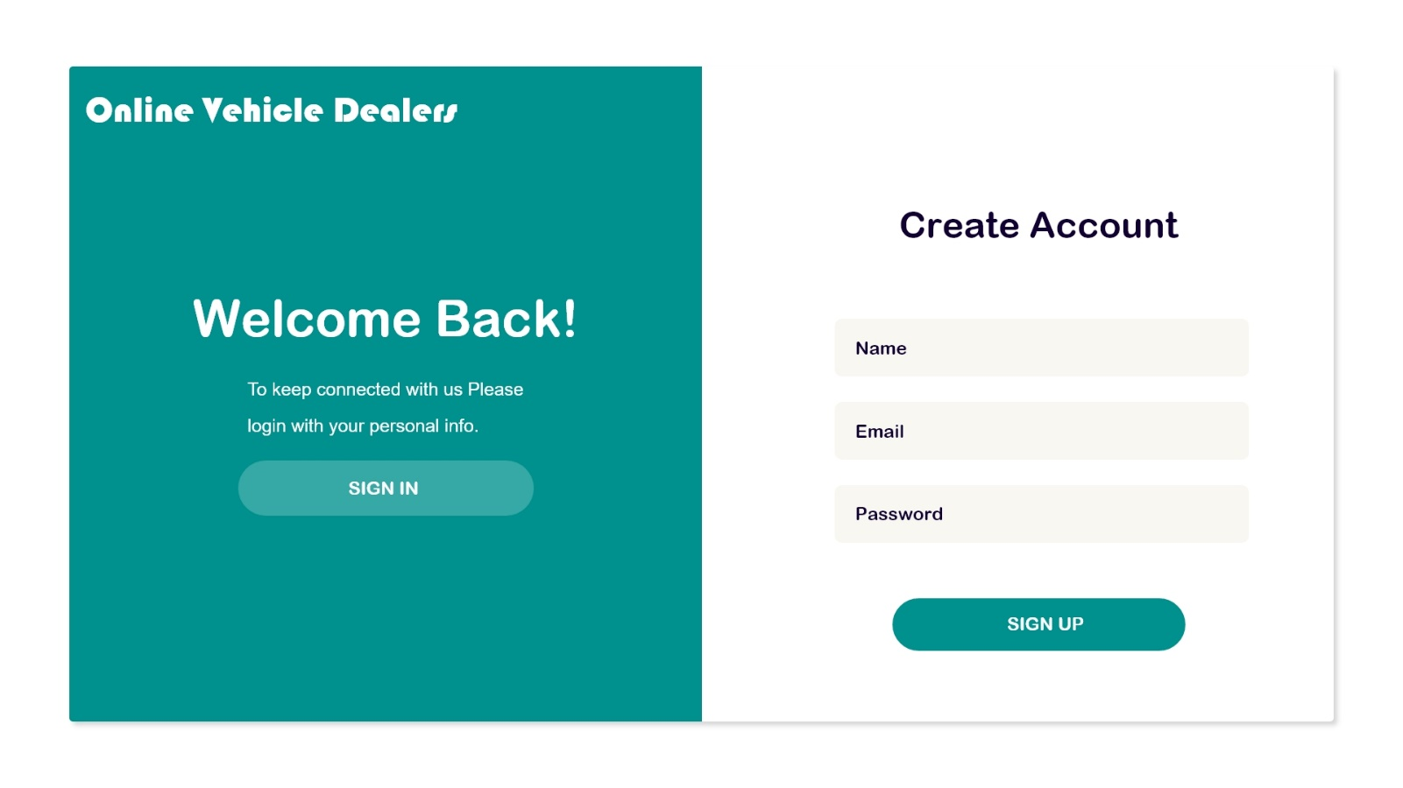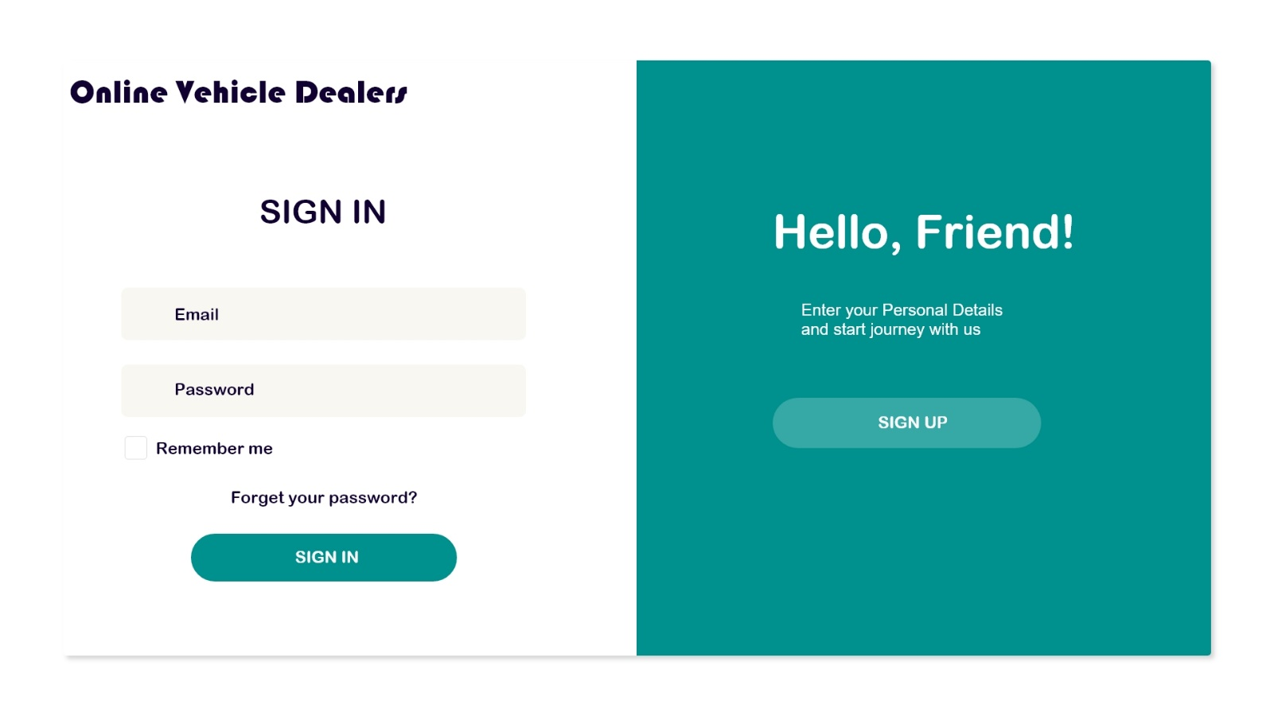

## 

## 

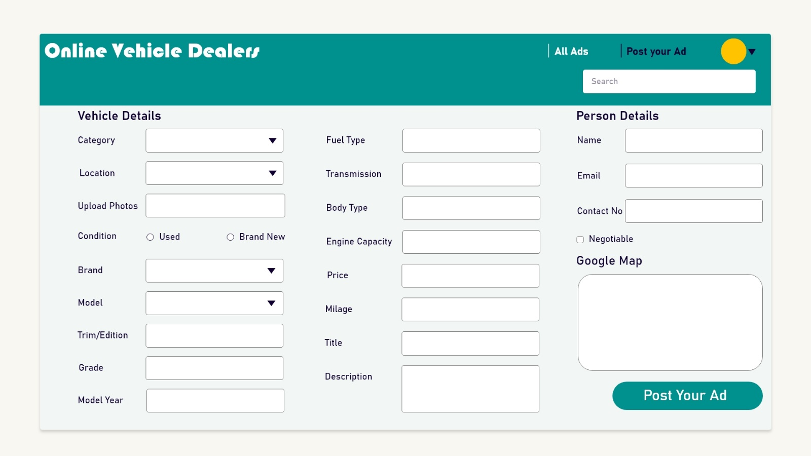

## Database relationship (ER) diagram

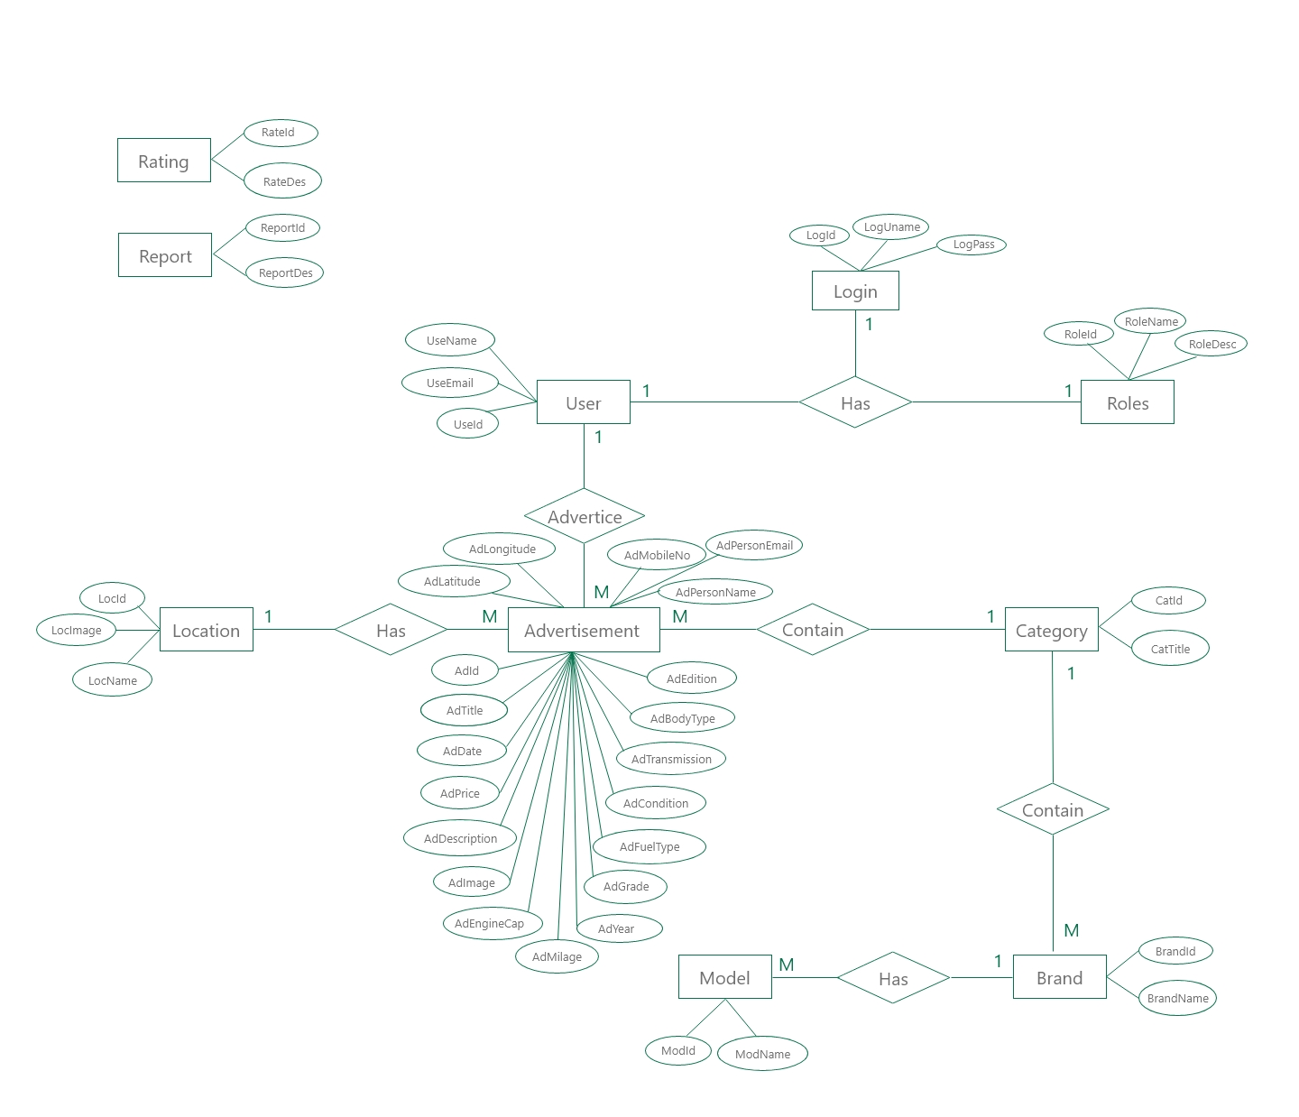

## Use Case Diagram

### Use Case Description for Create Account

|  |  |
| --- | --- |
| **Use Case ID** | UC-01 |
| **Use Case** | Create Account |
| **Actors** | Registered Viewer, Advertiser |
| **Description** | User create a user account in the system |
| **Pre-conditions** | User must visit the web site  User shouldn’t have account with the same Email address existing in the system |
| **Basic course** | 1. User click ‘Sign Up’ button in home page 2. System display ‘Sign Up’ page 3. User enter details 4. User click ‘sign Up’ button 5. System check the validity of provided details   **[Valid]**  5.1a system allow user to sign up with a new account  **[Invalid]**  5.1b system display an error message  5.2b system redirect to ‘Sign Up’ Page |
| **Alternative course** | If the user already has an account created in system, then system direct to login page |
| **Exceptional course** | If there is an account already created with Email address provided by user, an error message is displayed by system  User is not allowed create more than one account with the same Email address |
| **Post condition** | New user account is created in system |

### Use Case Description for Login

|  |  |
| --- | --- |
| **Use Case ID** | UC-02 |
| **Use Case** | Login |
| **Actors** | Registered viewers, advertisers |
| **Description** | Users log into the system |
| **Pre-conditions** | User should have registered account created in the system |
| **Basic course** | 1. User visit website 2. Select ‘Log in’ tab 3. System display ‘Log in’ page 4. User enter username and password 5. Click ‘Log in’ button 6. System check the validity of username and password   **[Valid]**  6.1a Allow user to login to the system  **[Invalid]**  6.1b System displays an error message  6.2b System direct user to ‘Log in’ page |
| **Alternative course** |  |
| **Exceptional course** | If the user does not have an account created in system, System direct him to ‘create account page |
| **Post condition** | User logged into the system |

|  |  |
| --- | --- |
| **Use Case ID** | UC-03 |
| **Use Case** | Create Advertisements |
| **Actors** | Advertiser |
| **Description** | Advertiser add necessary details by filling an application and create advertisement |
| **Pre-conditions** | Advertiser should be logged into the system |
| **Basic course** | 1. Advertiser select ‘Post Ad’ option 2. System Display ‘Post Ad’ page 3. Advertiser enter necessary details of the advertisements 4. Advertiser click ‘Post Ad’ button 5. System displays ‘Options’ page 6. Advertiser select necessary options according to his requirements 7. System accepts details 8. System checks the validity of details 9. According to the validity of data   **[Valid]**  9.1a. System display advertisements in website according to advertiser’s requirements  **[Invalid]**  9.1b. System displays an error message  9.2b. System direct advertiser to ‘Post Ad’ Page to re-enter details |
| **Alternative course** |  |
| **Exceptional course** | If advertiser is not log in to the system, system directs him to ‘Login’ page. |
| **Post condition** | An advertisement is created in website |

**Use Case Description for create advertisements**

Use Case Description for View advertisements

|  |  |
| --- | --- |
| **Use Case ID** | UC-04 |
| **Use Case** | View Advertisements |
| **Actors** | Unregistered Viewer, Registered Viewer |
| **Description** | Viewer can view advertisements and filter advertisements according to his requirements |
| **Pre-conditions** | Viewer should visit website |
| **Basic course** | 1. Initially all the advertisements are appeared on home page according to the descending order of posting date and time. 2. Viewer can select an advertisement or search/sort advertisements according to his requirements 3. According to option he selects ‘select’, ‘search’, ‘sort’   **[Select]**  3.1a. Viewer select an advertisement out of all advertisements displayed in home page  3.2a. Viewer click on that advertisement  3.3a. System displays full advertisement to the viewer  **[Search]**  3.1b. Viewer type a keyword in the search bar provided in ‘Home’ page  3.2b. Viewer click on ‘Search’ button  3.3b. System display all the related advertisements to that keyword  3.4b. Advertiser click on one advertisement  3.5b. System displays full advertisement to the viewer  **[Sort]**  3.1c. Advertiser select and click on one of the sort options provided in home page  3.2c. System sort advertisements according to the option selected  3.3c. System display advertisements according to the sorted order  3.4c. Advertiser click on one advertisement  3.5c. System displays full advertisement to the viewer |
| **Alternative course** | If the particular viewer is a registered viewer and already log on to the system he can mark on favorite advertisements and reported on any suspected advertisements |
| **Exceptional course** | If no advertisements are available related to the keyword typed by user then system displays a message indicating “No Related Advertisements available” or a blank page is displayed |
| **Post condition** | Viewer view full advertisements related to his requirements |

### Use Case Description for Manage User Accounts

|  |  |
| --- | --- |
| **Use Case ID** | UC-05 |
| **Use Case** | Manage User Accounts |
| **Actors** | Registered viewer, Advertiser, Admin |
| **Description** | Registered viewers and Advertisers can create new account, update and delete an existing account  Admin can delete or block user accounts |
| **Pre-conditions** | User must be logged into the system |
| **Basic course** | 1. User select ‘Manage Account’ option 2. System display ‘Manage Account’ page 3. User can select ‘Create New Account’ option, ‘Update Account’ option, ‘Delete Account’ option   **[Create New Account]**  3.1a System display ‘Create New Account’ page  3.2a User enter details  3.3a System store details  3.4a System creates new account for user  **[Update Account]**  3.1b System display ‘Update Account’ page  3.2b User enter necessary details to be updated  3.3b User click ‘Update’ button  3.4b System update details of existing user account  3.5b System display “Successfully Updated message”  **[Delete Account]**  3.1b System display ‘Delete Account’ page  3.2b User select the account  3.3b User click ‘Delete’ button  3.4b System Display confirmation message  3.5b User confirm or ignore the deletion  **[Confirm]**  Delete the user account from the system  **[Ignore]**  Ignore the deletion |
| **Alternative course** | If the admin wants to block the account temporarily, he selects ‘Block Account’ option |
| **Exceptional course** |  |
| **Post condition** | Create, Update or delete user accounts according to user requirements |

### **Use Case Description for Manage Advertisements**

|  |  |
| --- | --- |
| **Use Case ID** | UC-06 |
| **Use Case** | Manage Advertisements |
| **Actors** | Advertiser |
| **Description** | Advertiser can Create new advertisement or delete, update existing advertisements |
| **Pre-conditions** | Advertiser should be logged into the system |
| **Basic course** | 1. Advertiser select ‘Manage Advertisement’ option 2. System display ‘Manage Advertisement’ page 3. Advertiser select Create, Update, Delete advertisement option   **[Create]**  3.1a System displays ‘Create Advertisement’ page  3.2a Advertiser enter details  3.3a Advertiser click ‘create’ button  3.4a System create new advertisement  3.5a System displays “successfully Created’ message  **[Update]**  3.1b System displays ‘Update Advertisement’ page  3.2b Advertiser select advertisement using ad code  3.3b Advertiser click ‘Update’ button  3.4b System update the details of advertisement  3.5b System displays ‘Successfully Updated’ message  **[Delete]**  3.1c System displays ‘Delete Advertisement’ page  3.2c Advertiser select advertisement using ad code  3.3c Advertiser click ‘Delete’ button  3.4c System Display confirmation message  3.5c Advertiser confirm or ignore the deletion  **[Confirm]**  Delete the Advertisement from the system  **[Ignore]**  Ignore the deletion |
| **Alternative course** |  |
| **Exceptional course** | If the advertisement has been already expired, then system displays an error message |
| **Post condition** | Create new advertisement or Update & Delete existing advertisements |

### Use Case Description for Comment, Rate on Advertisements, Report on Fraud Advertisements and Mark Favorite Advertisements

|  |  |
| --- | --- |
| **Use Case ID** | UC-07 |
| **Use Case** | Comment, Rate on Advertisements, Report on Fraud Advertisements and Mark Favorite Advertisements |
| **Actors** | Registered Viewer |
| **Description** | Viewer can put comments and rate on advertisement according to user experience. Viewer can report on suspected fraud advertisements and can mark favorite advertisements to refer in future |
| **Pre-conditions** | Viewer must be logged into the system |
| **Basic course** | 1. Viewer Click on one advertisement 2. System Displays full advertisement 3. Viewer select an option whether to comment, report, rate on advertisements or mark as favorite advertisement   **[Comment]**  Viewer type comment on comment box  Viewer click ‘Save’ button  System store the comment  System display that comment along with the advertisement  **[Rate]**  Viewer click on stars to rate  System records that rating  System calculate current rate on that advertisement  System display the current ratings with star rating system  **[Report]**  Viewer click on report button  System record the report of the viewer  System increases the number of reports on advertisement by 1  If number of reports on a particular advertisement is greater than 100 system automatically block the advertisement  **[Mark]**  Viewer click on ‘Save as favorite’ button  System save that advertisement in viewer’s account |
| **Alternative course** |  |
| **Exceptional course** | If the particular viewer is not logged on to the system, system displays an error message |
| **Post condition** | Viewer comment, rate, report, and save advertisements according to his requirements |

### Use Case Description for View Reports

|  |  |
| --- | --- |
| **Use Case ID** | UC-08 |
| **Use Case** | View Reports |
| **Actors** | Admin |
| **Description** | Admin can view reports according to his requirements |
| **Pre-conditions** | Admin should be logged into the system |
| **Basic course** | 1. Admin Select ‘View Report’ option 2. System display ‘View Report’ page 3. Admin select his requirements 4. System generate reports 5. System display report |
| **Alternative course** |  |
| **Exceptional course** |  |
| **Post condition** | Admin will be able to view reports |

## Business logic

* Shall be able to create advertisement by advertiser
* Shall be able to modify advertisement by advertiser
* Shall be able to delete advertisement by advertiser
* Shall be able to view advertisement by viewers
* Shall be able to sort advertisements by viewers
* Shall be able to search advertisements by viewers
* Shall be able to insert exact location of service or commodity via Google maps
* Shall be able to comment on advertisements by viewers

## Final screenshots

